What is the role of the World Trade Organisation (WTO)?
The WTO was set up in 1995 when it took over the General Agreement on Trade and Tariffs (GATT). The institution manages globalisation from a trade perspective at a global level, by setting trade rules. It tries to get rid of trade barriers and trade tariffs (tax on imports and exports) and sets the terms at which trade agreements between countries can be agreed. It also settles trade agreement disputes.

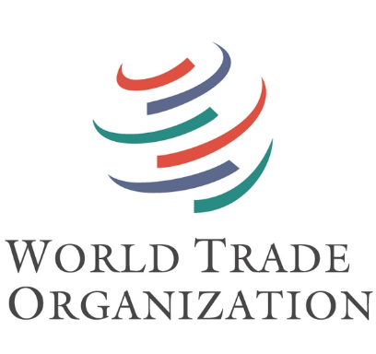

How does the WTO work?
The WTO currently has 164 members. It is run by a secretariat (department) of over 600 people in Geneva, Switzerland. The Director General is the head of the organisation. All major decisions about trade rules are made by the government ministers from the member countries at Ministerial Conferences, who meet at least every two years.
Decisions are normally taken by consensus. Gaining consensus among 164 countries is difficult. Some negotiations that started in a meeting in Doha in 2001 have still not come to an agreement. As a result, it has been suggested that the WTO system of decision making needs to be changed.

How are countries impacted by the WTO?
The WTO encourages trade liberalisation, the removal of barriers (such as import quotas and tariffs) that restrict the importation and exportation of goods and services between countries. This favours wealthy countries. For example Ireland’s agriculture industry is protected. However, for small farmers in Southern countries, the opening of trade markets has made it more difficult to earn a livelihood through farming. Poor countries are often forced to specialise in commodity production, such as growing coffee or tea. The commodities are sent to richer countries to be developed and sold, therefore the richer country makes the profit. WTO rules can be enforced through sanctions (penalties for breaking rules).
How is Ireland represented at the WTO?
Irish man Peter Sutherland was Director General of GATT from 1993 -1995, and also served as the first Director-general of the WTO from 1995-1995. Irish ministers attend the WTO Ministerial Conference held at least once every two years. It brings together all members of the WTO to make decisions on all matters of trade agreements.

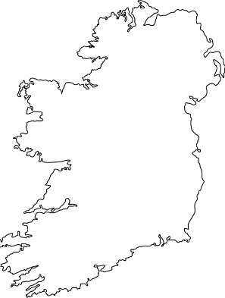
Go to the WTO’s website to research more information wto.org
- Who is the current Director General?

