What is the role of the
World Bank?

The World Bank was created in 1944 to rebuild the economies of Northern countries after World War II. The World Bank tackles world poverty by lending money for development projects, and providing technical assistance to Southern countries. It provides money for large infrastructure projects (e.g. building roads), and for social projects in the area of health and education.

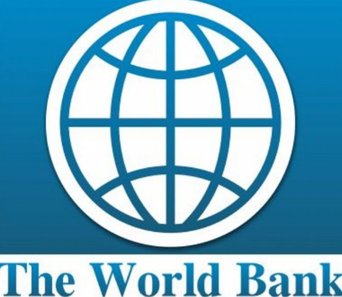

How does the World Bank work?
It is funded by the governments of the 189 member countries, and by the interest paid on loans it gives to Southern countries. A country’s influence in the World Bank is determined by the amount of money they pay in. Each member government is a shareholder of the Bank, and the number of shares a country has is based on roughly the size of its economy. The more money a member country pays in, the greater influence it has on making decisions. The most powerful members are the G8 countries - they have the most seats on the board of directors at the World Bank. The G8 countries are Canada, France, Germany, Italy, Japan, Russia, the United Kingdom and the United States. 48% of the votes come from G8 members.
The headquarters are in Washington D.C., United States. The president of the World Bank is usually appointed by the United States government.

How are countries impacted by the World Bank?
It is the world’s biggest lender of money. The loans to Southern countries come with conditions attached to them. This means that in order to get loans, countries must agree to make changes such as privatisation of public services.
How is Ireland represented at the IMF?
Ireland’s Minister for Finance is Governor for Ireland at the IMF and World Bank. Governors and officials from the two institutions have joint spring and autumn meetings. Ireland is part of a constituency made up of Canada, Ireland and 11 Caribbean countries and is represented in the IMF and World Bank by Canadian Executive Directors.

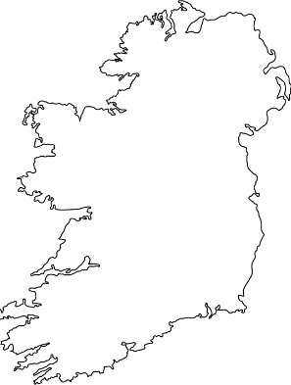
Go to the World Bank’s website to research more information about the institution. worldbank.org
- Who is the current president of the World Bank?
- The World Bank consists of five organisations, what are they?
- Look at the annual report to find out more about the work.

