What is the role of the United Nations Development Programme (UNDP)?
The United Nations in an intergovernmental organisation that promotes cooperation between countries. It was set up in 1945 after World War II to replace the League of Nations and to prevent such a conflict from happening again. The UNDP is the global development network within the United Nations. It works towards the reduction of poverty, inequality and exclusion in the world’s poorest countries, by providing advice, training and grants. The Sustainable Development Goals (SDGs) guide the work of the UNDP. Each year the UNDP produces a Human Development Repot - an important tool for raising awareness about human development around the world.

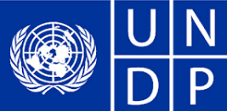

How does the UNDP work?
The organisation works with local governments in 177 countries. The UNDP Executive Board is made up of representatives of 36 countries around the world who serve on a rotating basis. It is responsible for supervising the activities of the UNDP. The Administrator is the highest ranking person in the UNDP. Funding from the organisation comes from governments, international financial institutions (e.g. World Bank), the private sector and foundations. Its headquarters are in New York City, United States.
How are countries impacted by the UNDP?
The UNDP helps improve people’s livelihood (means of securing life’s basic necessities such as food, water, medicine, shelter). The programme also helps people gain access to legal aid and energy. It works with communities to develop plans to be better prepared when a disaster happens, in particular relating to the climate.
Ireland’s relationship with the UNDP
The UNDP does not work in Ireland. But the Irish Government supports the UNDP to widen the reach of Ireland’s own development programme, Irish Aid. The relationship between Irish Aid and the UNDP can contribute to tackling development issues in countries that Ireland does not have a programme in. The Irish government contributed almost €7.8 million to the UNDP in 2015.

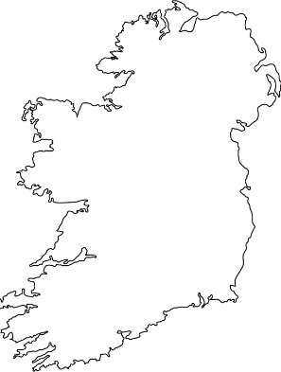
Watch https://www.youtube.com/watch?v=lEIwRV49o-Q
Go to the UNDP’s website to research more information undp.org
- Who is the current administrator?
- Look at the most recent human development report.
- Find out more about the SDGs.

