Theme: Interdependence
Aim: To understand the concept of interdependence through mapping the production trail of a mobile phone

Fairphone is an ethical phone company. It aims to create positive social and environmental impact from the beginning to the end of a phone’s life cycle. The company aims to only use fair materials in their phones. They trace where the phone’s parts come from and create a demand for materials that are good for people and planet. The company also strives to ensure that the people involved in producing the phone have good working conditions. By opening up the phone’s supply chain Fairphone want to start a discussion about where products come from and how they are made.

A mobile phone contains over 30 non-renewable minerals. Tantalum and tin are two metals that come from those minerals. Tin is used to make soldering paste, a paste that is used to connect chip packages to attachment points (lands) on a printed circuit board. The paste is usually applied to these lands using a stencil to “print” the paste. Tantalum is extracted from the ore colombite-tantalite. It is used to make capacitors, a tiny, heat resistant electrical component in your phone that can store and discharge electrical charges.
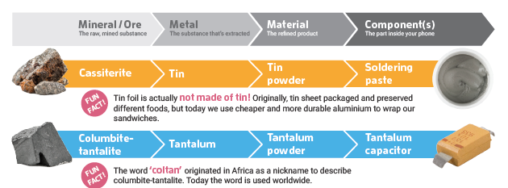
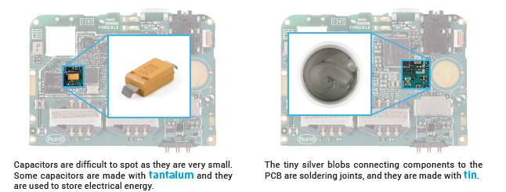

QUIZ
- What is the difference between a mineral and a metal?
- There is no difference
- A metal is a rock from which the metal is extracted
- A metal is an element, generally extracted from a mineral

- Which mineral is used in the largest quantity in a mobile phone?
- Copper
- Tin
- Tantalum

- Do all of the components from your phone come from the same country?
- Yes, they all come from China
- No, they are from different countries in Europe
- NO, the minerals, metals and components in your phone come from a global and interdependent supply chain

- What can be the capacitor’s function?
- Store energy
- Power the phone
- Increase memory capacity

- What is a conflict mineral?
- A mineral mined in a conflict area where the profits are used to fund the conflict
- Any mineral mined in a conflict area
- A mineral not related to war or conflict

- In a Fairphone, where can you find conflict free minerals from the Democratic Republic of Congo (DRC)?
- Solder
- Electroplating
- Vibration motor

- Where can you find tin inside your phone?
- Tin foil
- Soldering paste
- There is no tin in my phone

DIFFERENT PERSPECTIVES
Key question: Can perspective influence maps?
- Write in big writing on an A4 sheets Czech Republic, India, China, Malaysia, Tanzania and Democratic Republic of the Congo (DRC). Clear a large space on the ground to create a world map. Ask students to create a world map using the country labels.
- When they have the world map laid out challenge why they laid the countries out the way they did. The map we are used to looking at is our European perspective. We are used to seeing Europe in the middle. How would the map look if they were laying it out from a Chinese perspective or an Australian perspective? Move the country labels to reflect the discussion.
- After the discussion show the students a range of maps from different perspectives to demonstrate your argument.

VIDEO
Key question: Where do the minerals in our phone come from?
- Tell students that they are going to map the production trail of tin and tantalum. The journey begins in DRC. Watch the video which shows the tin and tantalum mines in DRC. Discuss: What are the working conditions like? What do you think happens the tin and tantalum next?

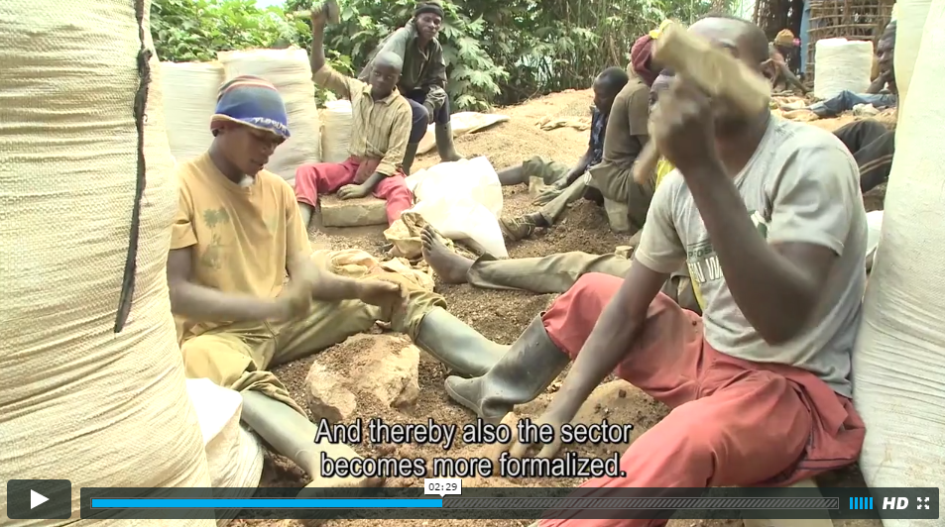

MAPPING THE PRODUCTION TRAIL
Key question: Are countries dependent on each other for the production of a mobile phone?
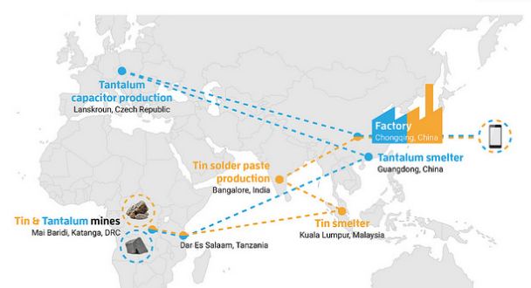
- Beginning with tantalum, give each of the pictures to a different student and ask them to stand at the country they think the moment of production takes place in. Move them if they are not correct.
- Using a piece of string, map put the trail of the tantalum.
- Repeat the process with tin. It is useful to use a different colour string.
Debrief:
Remind the students that the tin and tantalum is only a tiny part of their phone, there are also many other parts of their phone that have to be added before it makes it into their hands. Can they add any people/companies to the production trail? What would happen if one of the countries fell out of the production trail? Is this interdependent production a good or a bad thing? Does it impact on people/the environment? Would it be possible to make a mobile phone from start to finish in Ireland?
Tantalum Images
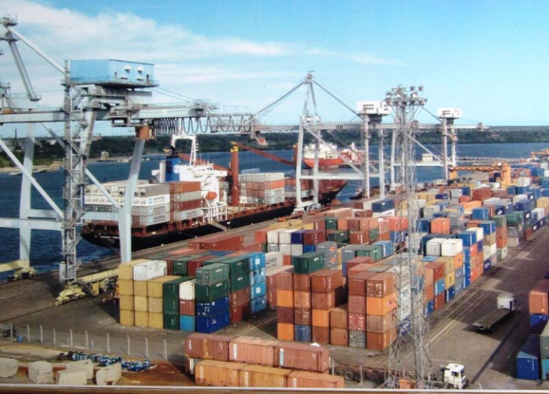 | The tantalum is brought to Dar Es Salaam, Tanzania, to be shipped to the next country by sea.
Need to find an image | Tantalum Smelter China
Need to find an image | Tantalum capacitor production, Czech Republic
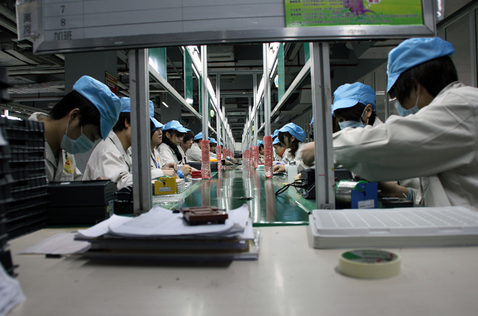 | Assembly in a factory in China
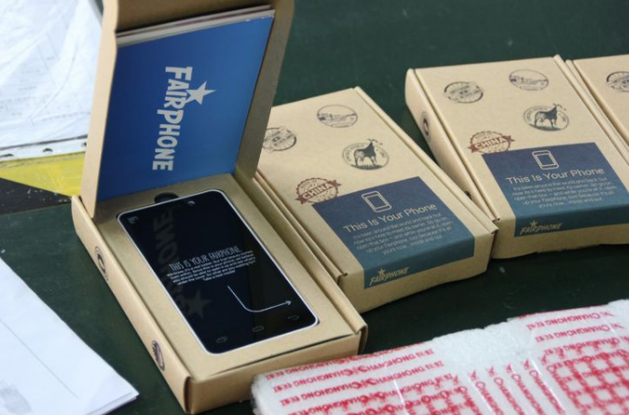 | Packaged in the Netherlands
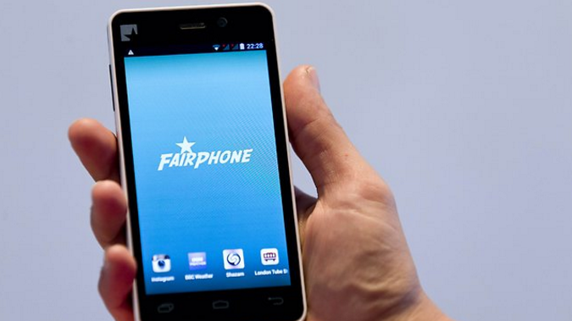 | In the consumer’s hand in Ireland

Tin Images
 | The tin is brought to Dar Es Salaam, Tanzania, to be shipped to the next country by sea.
Need to find an image | Tantalum smelter, China
Need to find an image | Tin solder paste production, India
 | Assembly in a factory in China
 | Packaged in the Netherlands
 | In the consumer’s hand in Ireland

DATA
Key question: How does European Commission roaming policy affect young people in Ireland?
The European Commission decides roaming charges in Europe. Does this have a positive of negative affect on young people in Ireland? https://ec.europa.eu/digital-single-market/en/roaming
Eir Connected Living Survey is a nationwide survey undertaken by Eir to help understand the usage of technology in Irish homes. Some results of the survey published in November 2015 can be seen in this infographic https://www.eir.ie/opencms/export/sites/default/.content/pdf/pressreleases/portrait_eir-connected_living_survey-infographic.pdf

HOMEWORK TASKS
This lesson had been adapted from a Fairphone mining workshop, designed for education settings. For more detailed information and activities about what is in your phone and how to recycle it activities go to fairphone.com/en/community/tell-our-story/
Exploitation of workers and resources often occurs in conflict areas, where mines and mineworkers have been controlled by armed forces who use the high mineral revenues to finance their armies. Explore how some mines are fuelling conflict in DRC, are the workers being exploited? Global Witness is an organisation that campaigns against environmental and human rights abuses globalwitness.org

Investigate the production trail of other phone companies and see how they compare to Fairphone

Investigate how a flip flop is made at flipfloptrail.com

