What is the role of the
International Monetary Fund (IMF)?

The IMF was created in 1944 with the aim of creating global economic stability and improved global cooperation. The institution surveys national economic policies and discourages policies it believes have negative effects on the global economy. It also provides short term and long term loans to countries.

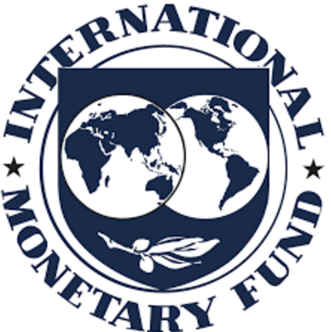

How does the IMF work?
It is funded by its 189 member countries, which pay a subscription when they join. This amount is based on the size of the country’s economy, which also determines the size of their vote – the richer the country the bigger the vote. The United States has 17% of the votes, while countries of the whole African continent have only 6% of the vote. Ireland has 0.5% of a vote.
The headquarters is in Washington D.C., United States. The 24 member Executive Board is responsible for selecting the Managing Director.

How are countries impacted by the IMF?
The IMF often acts as a ‘gatekeeper’ to debt relief and aid. Because the IMF has such a powerful voice, sometimes donor countries have to hold back their aid to Southern countries until the IMF gives approval. The IMF impose Structural Adjustment Programmes (SAPs) on countries that they loan to such as the privatisation of public services. Ireland’s water charges are an example of this. The IMF is sometimes referred to as the ‘lender of last resort’. The IMF and World Bank often work together in deciding policy conditions.
How is Ireland represented at the IMF?
Ireland’s Minister for Finance is Governor for Ireland at the IMF and World Bank. Governors and officials from the two institutions have joint spring and autumn meetings. Ireland is part of a constituency made up of Canada, Ireland and 11 Caribbean countries. Ireland is represented in the IMF and World Bank by Canadian Executive Directors.

Go to the IMF’s website to research further information about the institution. www.imf.org/
- Who is the current Managing Director?
- What countries are the biggest borrowers?
- The IMFs’ work consists of surveillance, lending and capacity building – find out more about each of these.
