Theme: Globalisation
Aim: To explore the positive and negative aspects of globalisation

3-2-1 BRIDGE
- Students fill out their own initial responses to globalisation by using a 3-2-1 bridge.
- Facilitate a class discussion by asking them to share their response.
- Ask students to fill it out again at the end of this section. Have their responses changed?
 | Your initial response to ‘globalisation’ | Your new response to ‘globalisation’
3 thoughts/ideas
2 questions
1 analogy

DEFINING GLOBALISATION
Key question: What is globalisation?
- Divide students into groups. Give a set of definitions to each group. Ask students to categorise them into social and economic. There is no correct way to categorise them, the exercise is to encourage the students to discuss and interpret each definition.
- Ask them to select the definition of globalisation that they align themselves with. They should be able to explain why.
- Using the underlined key words, ask the groups to come up with their own definition, write on large sheets of paper and stick on the wall. Encourage students to walk around and read each definition.
Globalisation describes different world cultures becoming incorporated into one dominant culture which will eventually cover the whole world. (Featherstone 1995) | Globalisation refers to the process of the world being seen more and more as one place. And the awareness that it is happening. (Robertson 1992)
Globalisation is a term to describe the rapid flow of capital (money), people, goods, images and ideas across countries in an interconnected web, compressing our sense of time and space, making the world seem smaller. (Xavier and Rosaldo 2001) | Globalisation brings faraway places closer together by the strengthening of worldwide social relationships. The affects from events happening many miles away can be felt locally. (Giddens 1990)
Globalisation refers to the linking of countries, the expansion of the market economy, and society becoming more integrated. (Lechner and Boli 2004) | Globalisation refers to all the contemporary processes that make distance irrelevant (Hylland Eriksen 2014)

PICTURING GLOBALISATION
Key question: Is globalisation a good or a bad thing?
Using photographs:
Photographs are a great resource for exploring global issues and developing empathy amongst your students. A critical examination of photographs encourages students to challenge their perceptions of an issue and enables them to come to their own conclusions. Photograph methodologies allow students to be creative, and can often give quieter students an opportunity to be heard.
Log onto xxxxx to access photographs selected for the following activities. Alternatively, you can ask students to bring their own photographs that represent globalisation.
A code of conduct on images and messages has been written by NGOs working in the area of emergency relief, long term development and development education. The code offers a set of guiding principles for taking and using photographs, to ensure that people’s dignity are being respected in the photographs. Log onto dochas.ie/code-resources to find information about the principles to help you select photographs.

Selection
Place the photographs on the ground. Ask students to walk around and stand at:
- A photograph that they are curious to find out more about.
- A photograph that reminds them of something in their own lives.
- A photograph that makes them angry.
Discuss with the other students who stood at that picture, and ask them to feed back to the larger group.
Questioning the Photograph
- Give each group a sheet of flipchart paper. Stick their photograph in the middle and ask them to write questions around the border. The aim of this activity is not to find answers to the questions, but rather to begin critically analysing what is happening in the photograph.
- Encourage deeper discussion by asking the students why they wrote the question.
Place Yourself Inside the Photograph
- Using a sticky note, ask students to draw themselves and stick themselves in the photograph. Describe what they can see, smell, hear. How do they feel? What is the atmosphere in the photograph?
Beyond the Photograph
- On the back of the flipchart paper, place the image in the centre of the page. Ask students to draw what they think is outside the photograph, but was not captured by the camera.
What’s On Their Mind?
- Give out sheets of paper with a speech/though bubble to each group. Encourage students to select a person in the photograph and write what they are thinking/saying.
- Share with the group why they wrote what they did.
Categorising the Photographs
- Place a flashcard saying positive on one wall and a flashcard saying negative on the other side of the room. Ask students to sand at the positive side if they think their picture represents a positive aspect of globalisation, on the negative side of it represents a negative aspect, and in the middle if they think both. They must justify their decision.
- Encourage other students to debate their position. Allow to them to move if they are convinced by an argument.

HOMEWORK TASK:
Select a person in the photograph and write a diary entry from their perspective. Encourage students to think beyond the photograph, writing about things that the person may have experienced that was not captured in the photograph. Ask them to include an element that refers to either a positive or negative aspect of globalisation.

DATA
Key question: How does Ireland rank in the globalisation index?
Authors Dreher, Gasten and Martens attempt to measure globalisation in their book Measuring Gobalisation: Gauging its Consequences. The book includes an update of the KOF Globalisation Index. This index conceptualises globalisation as having three main dimensions: economic, social and political globalisation. Economic globalisation refers to flows and restrictions of goods and services. Social globalisation measures the spread of ideas, images, people and information. Political globalisation measures. Political globalisation refers to the spread of political policies.
Investigate where Ireland ranks on the KOF Globalisation Index globalization.kof.ethz.ch/ The detailed rankings are available in a PDF at the right hand corner of the web page. Discuss examples of why Ireland is ranked where it is.

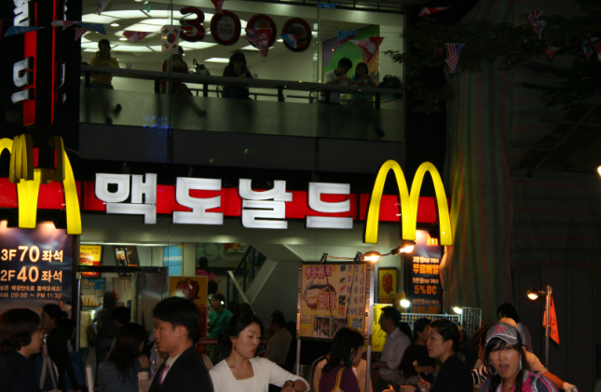
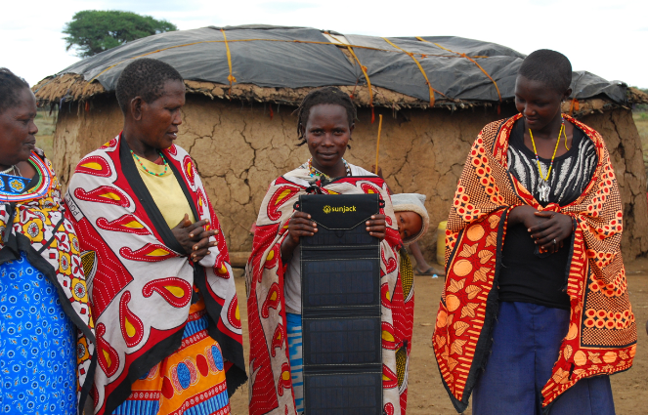
Made in Banglaadesh – take photo myself
Food, vegetable market – tale photo myself

References
Eriksen, Thomas Hylland 2014. Globalization: The key concepts. Bloomsbury
Dreher, Axel; Noel Gaston and Pim Martens, 2008. Measuring Globalization - Gauging its Consequence, New York: Springer
Featherstone, Mike 1995. Undoing culture: Globalization, post-modernism and identity. Sage Publications.
Giddens, Anthony 1990. The consequences of modernity. Polity Press.
Inda, J. X and R. Rosaldo (eds), 2002. The Anthropology of Globalization. Blackwell
Lechner, F. J and J. Boli 2000. The Globalization Reader. Blackwell
Robertson, R. 1992. Globalization. Sage

