DEBT AND DEVELOPMENT COALITION IRELAND
World Bank - IMF Watch 2013
SUMMARY RECOMMENDATIONS
/////////////////////////////////////////////////////////////////////////////

IRELAND, THE WORLD BANK AND IMF IN 2013: WORKING FOR THE PEOPLE OR FOR BIG FINANCE?

Are the World Bank and IMF working for the people or for big finance? This years World Bank-IMF Watch focuses on a number of areas where the international financial institutions (IFIs) are, sadly, hurting the lives of people in the Global South. As Europe grabs the attention on debt issues, the continued debt distress of Southern nations has fallen off the international agenda. World Bank – IMF Watch 2013 shows how unsustainable and often illegitimate debts continue to be repaid by Southern nations. We highlight how Argentina awaits the judgment of a United States (US) court on whether an opportunistic “vulture fund” can claim over a billion dollars from its coffers. How the people of Zimbabwe wait to see if they must repay debt arrears accumulated over decades of unjust rule and dodgy international lending relationships. How Jamaica is being put through yet another round of austerity measures, while the IFIs fail to support outright debt cancellation.

World Bank – IMF Watch 2013 concentrates on a number of current, critical developments at the IFIs which are of high concern to justice groups worldwide. At the World Bank Group, we highlight how the current review of the well known World Bank Doing Business Rankings must address the narrow and often damaging economic policies they promote. We put the spotlight on the International Finance Corporation (IFC), an arm of the World Bank Group, and the sometimes devastating social and environmental effects of its investments in the financial sector. At the IMF, we question the continued promotion by the IMF of taxes that disproportionately hurt poor people and its continued failure to instigate meaningful governance reform.

Ireland has contributed over €150 million to the World Bank Group and IMF over the past 3 years. It is commendable that Ireland seeks to invest its largest contributions in elements of the World Bank and IMF that target finance toward the most impoverished people. However, Ireland cannot stay silent on the serious policy failures at the IFIs outlined here. This report comes just weeks after the Irish Government launched its follow-up to the White Paper on Irish Aid (2006) titled One World, One Future: Ireland’s Policy for International Development (2013). Given the new policy document’s strong focus on
“demonstrating results” the Irish Government must become more accountable and show how its membership of the IFIs contributes toward poverty eradication and the reduction of inequality.

RECOMMENDATIONS FOR IMPROVED IRISH GOVERNMENT ACCOUNTABILITY

The report outlines a set of recommendations for action on specific debt related issues. However, we also ask the Government to become more accountable in its decision-making process with the IFIs. Specifically, Debt and Development Coalition Ireland calls on the Irish Government to:

• Publish the policy objectives that Ireland is pursuing at the IFIs. These should ideally be outlined in the currently unpublished, revised international debt policy undertaken by the Dept. of Finance and the Dept. of Foreign Affairs and Trade in 2009.
• Establish monitoring and evaluation mechanisms for tracking progress toward meeting these objectives. This should include reference to ongoing IFI evaluations that are informing Ireland’s decision making and spending. Ireland should carry out independent, periodic reviews to account for the impact of public spending, amounting to over €150 million over the past 3 years, at the IFIs vis-à-vis our national development policy objectives.
• Initiate an annual Oireachtas debate on Ireland’s participation at the IFIs to support parliamentary input into Ireland’s decision-making.
• Initiate a discussion on the issues arising from the Annual Report on Ireland’s Participation at the World Bank and IMF at the Inter-Departmental Committee for Policy Coherence, chaired by Minister for Trade and Development Joe Costello T.D, with opportunities provided for civil society participation.

RECOMMENDATIONS FOR DEBT & TAX JUSTICE

This annual report is part of DDCI’s monitoring work, and in 2013 focuses on the following debt related issues which DDCI believes require urgent attention:

1. The need for debt audits and cancellation of unsustainable and illegitimate debts in Southern countries
2. The negative impact of the World Bank’s Doing Business Report on economic planning in countries of the Global South
3. The damaging impact of the International Finance Corporation of the World Bank Group through its
investment in “financial intermediaries”
4. The IMF’s promotion of regressive tax policy loan conditions, especially consumption taxes
5. Southern countries’ demand for fundamental governance reform at the IMF

DDCI ASKS THE IRISH GOVERNMENT TO:

Debt Cancellation, Debt Audits
Work to put debt cancellation needs of Southern countries back on the World Bank and IMF agenda including by:
• Supporting immediate debt write downs for countries with high levels of debt distress, like Jamaica;
• supporting debt audits where questionable loans were extended and support debt cancellation where appropriate, such as in the Zimbabwe case;
• working for internationally agreed fair and responsible lending and borrowing practices in future.

Vulture Funds
• Initiate legislation which severely curbs the level that vulture funds can profit from the purchasing of distressed debt and ensure that any existing national debt re- structuring agreements also apply to such funds.

World Bank Group - Doing Business Rankings
• Support the suspension of the rankings element of the report until the purpose and content of the report as a development tool is clearly defined. Particular attention should be put to improving its labour and tax policy analysis by becoming relevant to small and informal businesses in the global South.

World Bank Group - International Finance Corporation
• Call for suspension of IFC investment in cases such as that of the Cambodia and Laos landgrabs and other cases that are under review by the CAO
• Support a fundamental review of the purpose and modalities of IFC investment in the financial sector. The Irish Government should cease to invest in the IFC financially or through creating linkages between the IFC and the Irish private sector without this fundamental overhaul taking place.

IMF – Taxation policy
• Advocate that the IMF stop applying increases in regressive taxes such as VAT as a source of quick win revenue collection and instead focus on supporting fair burden sharing of tax that focuses on progressive, equity- based taxation policies.

IMF – Governance Reform
• Support much greater voice and vote of Southern countries at the IMF through supporting a double majority voting system whereby the current quota-based voting system would be combined with a “one state – one vote” model such as used by the United Nations.
• Support an end to the archaic arrangement of Europe appointing the head of the IMF and the US appointing the head of the World Bank.

/////////////////////////////////////////////////////////////////////////////////////////////////////////////////

IN BRIEF:
What are the IMF and World Bank?
The International Monitory Fund (IMF) has 188 member countries. It monitors the economies of its member countries, gives economic policy advice, and acts as the lender of last resort to borrowers who are then subject to loan policy conditions. In 2009, the G202 decided that the IMF should lead in responding to the financial and economic crisis, and committed to quadrupling the Fund’s resources from US$ 250 billion to US$ 1 trillion.

The World Bank has 188 member countries. It provides financial and technical resources to Southern countries, and has a specific poverty reduction mandate. The World Bank Group works through five institutions, which have different roles.3 In 2012, the World Bank Group committed US$ 52.6 billion in loans, grants, equity investments, and guarantees to its members and to private businesses.4The governments that borrow from the World Bank are required to adopt policy changes in return for loan financing.

Ireland became a member of both bodies in 1957.

////////////////////////////////////////////////////////////////////////////////////////////////////////////////////////////
About Debt and Development Coalition Ireland
Debt and Development Coalition Ireland (DDCI) is a membership organisation working for global financial justice. As an independent civil society organisation, one of our roles is to examine the work of the International Financial Institutions (IFIs), the World Bank and the International Monetary Fund, and the impact their policies have on the lives of millions of people around the world. We track the policies of the Irish government which represents the people of Ireland as a member of both the World Bank and the IMF, and support interested citizens and parliamentarians to hold the government to account in policy-making in this area.

Debt and Development
Coalition Ireland
Unit F5
Spade Enterprise Centre
North King Street
Dublin 7
Ireland
T: + 353 1 6174835
F:+ 353 1 6174889
E: campaign@debtireland.org
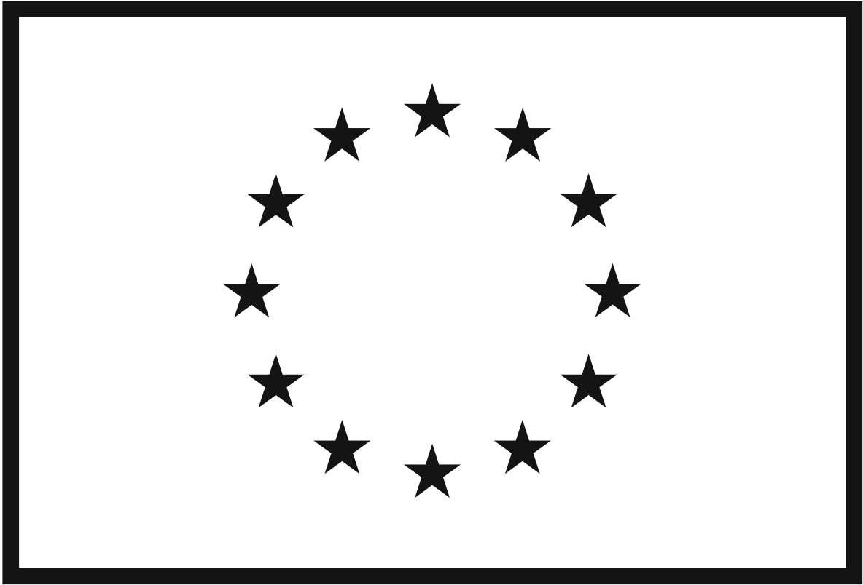 Disclaimer: This report has been held with the assistance of the European Union. The contents are the sole responsibility of Debt and Development Coalition Ireland and can in no way be taken to reflect the views of the European Union.

DDCI would also like to express its gratitude to Trócaire for its support toward its work.

///////////////////////////////////////////////////////////////////////////////////////////////////////////////

DDCI uses the terms ‘North/South’, or ‘Global North /Global South’ rather than ‘First World/Third World or ‘Developed/Developing’ countries. We use them as a short hand in a way that seeks not to imply superiority or inferiority between people.

